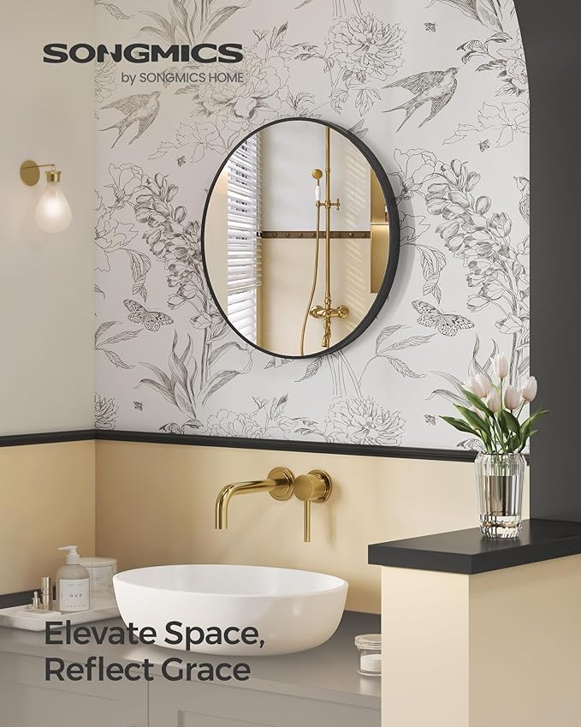

$38

SONGMICS Round Mirror, Bathroom Mirror for Wall, 24 Inches, Metal Frame, Easy to Install, for Bathroom, Living Room, Bedroom, Entryway, Hallway, Ink Black ULWM102B01